1. **Add a new art object to the museum’s permanent collection.**

**Before**:

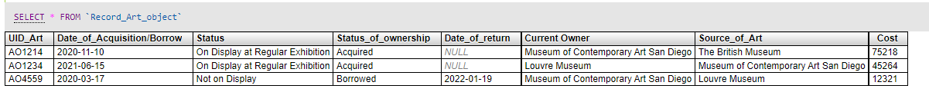

**Query:**

INSERT INTO `Record_Art_object` (`UID_Art`, `Date_of_Acquisition/Borrow`, `Status`, `Status_of_ownership`, `Date_of_return`, `Current Owner`, `Source_of_Art`, `Cost`) VALUES ('AO1558', '2021-11-22', 'Not on Display', 'Acquired', NULL, 'Louvre Museum', 'Salvatore Garau', '5856');

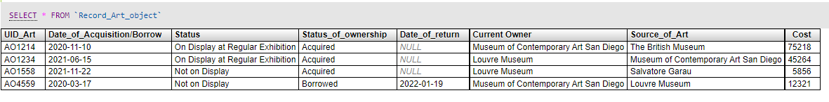**After:**

1. **Change the end date of a fetured exhibition.**

**Query:**

[UPDATE](https://local.abdn.ac.uk/mysql/phpmyadmin/url.php?url=https://dev.mysql.com/doc/refman/5.5/en/update.html) `Exhibition` [SET](https://local.abdn.ac.uk/mysql/phpmyadmin/url.php?url=https://dev.mysql.com/doc/refman/5.5/en/set.html) `End_Date` = '2022-03-11' WHERE `Exhibition`.`Type_of_Exhibition` = 'COLLECTIVE' [AND](https://local.abdn.ac.uk/mysql/phpmyadmin/url.php?url=https://dev.mysql.com/doc/refman/5.5/en/logical-operators.html#operator_and) `Exhibition`.`Start_Date` = '2021-12-07' [AND](https://local.abdn.ac.uk/mysql/phpmyadmin/url.php?url=https://dev.mysql.com/doc/refman/5.5/en/logical-operators.html#operator_and) `Exhibition`.`End_Date` = '2022-03-09';

**Result:**

1. **List all the borrowed art objects**

**Query:**

[SELECT](https://local.abdn.ac.uk/mysql/phpmyadmin/url.php?url=https://dev.mysql.com/doc/refman/5.5/en/select.html) * FROM PublicArt_Object,Record_Art_object WHERE PublicArt_Object.UID_Art=Record_Art_object.UID_Art [AND](https://local.abdn.ac.uk/mysql/phpmyadmin/url.php?url=https://dev.mysql.com/doc/refman/5.5/en/logical-operators.html#operator_and) Record_Art_object.Status_of_ownership='Borrowed';

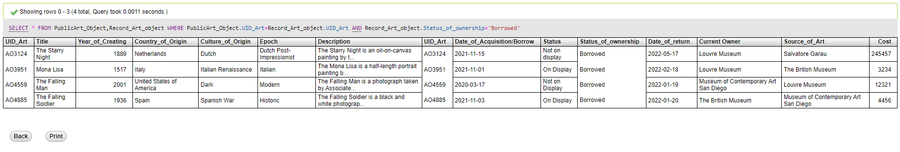**Result:**

1. **Count the number of art objects created by a given artist.**

**Query:**

SELECT Artists_Name,COUNT(*) as NumberofArt FROM Artists,Painting WHERE Artists.Artists_Name=Painting.Artist_Name AND Artists.Artists_Name='Leonardo' GROUP BY Artists_Name

UNION ALL

SELECT Artists_Name,COUNT(*) as NumberofArt FROM Artists,Sculpture_Statue WHERE Artists.Artists_Name=Sculpture_Statue.Artist_Name AND Artists.Artists_Name='Leonardo' GROUP BY Artists_Name

UNION ALL

SELECT Artists_Name,COUNT(*) as NumberofArt FROM Artists,others WHERE Artists.Artists_Name=others.Artist_Name AND Artists.Artists_Name='Leonardo' GROUP BY Artists_Name;

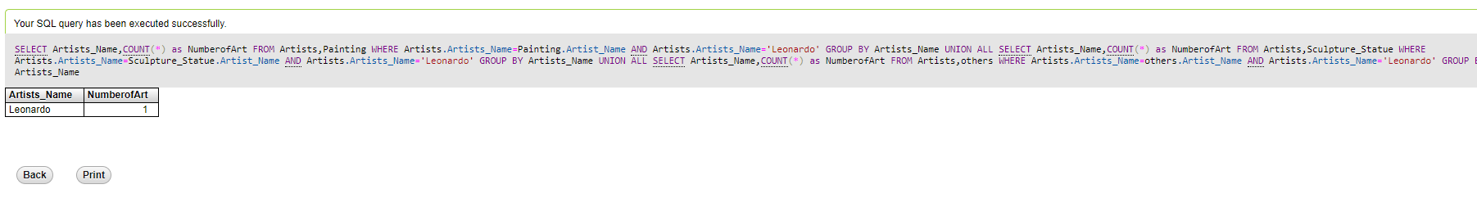**Result:**

1. **Count the number of art objects per type displayed in the regular exhibition and sort the list.**

**Query:**

SELECT PublicArt_Object.Type,Count(*) FROM PublicArt_Object,Record_Art_object WHERE Record_Art_object.Status LIKE ‘%Regular Exhibition’ AND PublicArt_Object.UID_Art=Record_Art_object.UID_Art GROUP BY PublicArt_Object.Type;

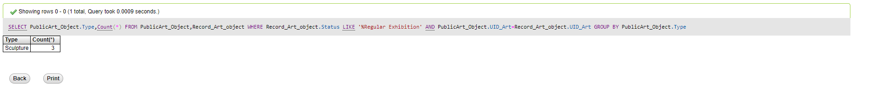**Result:**

1. **List all the art objects borrowed from a given museum in the ‘Arts Friend Circle’.**

**Query:**

[SELECT](https://local.abdn.ac.uk/mysql/phpmyadmin/url.php?url=https://dev.mysql.com/doc/refman/5.5/en/select.html) PublicArt_Object.Title,Record_Art_object.Source_of_Art FROM PublicArt_Object,Record_Art_object,Arts_Friend_Circle WHERE PublicArt_Object.UID_Art=Record_Art_object.UID_Art [AND](https://local.abdn.ac.uk/mysql/phpmyadmin/url.php?url=https://dev.mysql.com/doc/refman/5.5/en/logical-operators.html#operator_and) Record_Art_object.Source_of_Art=Arts_Friend_Circle.Name_of_Museum [AND](https://local.abdn.ac.uk/mysql/phpmyadmin/url.php?url=https://dev.mysql.com/doc/refman/5.5/en/logical-operators.html#operator_and) Record_Art_object.Status_of_ownership='Borrowed';

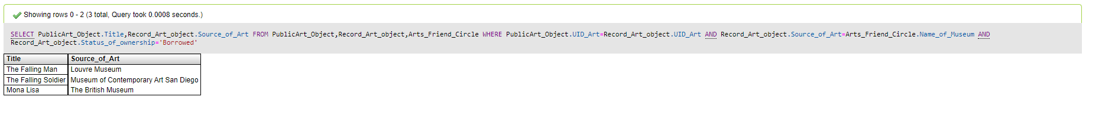**Result:**

1. **List the staff supervising a given featured exhibition.**

**Query:**

[SELECT](https://local.abdn.ac.uk/mysql/phpmyadmin/url.php?url=https://dev.mysql.com/doc/refman/5.5/en/select.html) Staff.Name FROM Staff,Exhibition WHERE Exhibition.Featured='Yes' [AND](https://local.abdn.ac.uk/mysql/phpmyadmin/url.php?url=https://dev.mysql.com/doc/refman/5.5/en/logical-operators.html#operator_and) Exhibition.Display_Galleries=Staff.Galleries_Supervising;

**Result:**

1. **List all the curators responsible for maintaining a given art object**

**Query:**

[SELECT](https://local.abdn.ac.uk/mysql/phpmyadmin/url.php?url=https://dev.mysql.com/doc/refman/5.5/en/select.html) Staff.Name FROM Staff WHERE Staff.Specific_Art_id='AO1214';

**Result:**

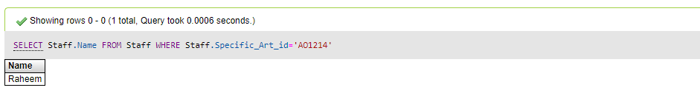

1. **List all the featured exhibitions along with their start and end dates and their loyal visitors**

**Query:**

[SELECT](https://local.abdn.ac.uk/mysql/phpmyadmin/url.php?url=https://dev.mysql.com/doc/refman/5.5/en/select.html) Exhibition.Name_of_Exhibition, Exhibition.Start_Date,Exhibition.End_Date,Loyal_Visitors.U_Loyality_no FROM Exhibition,Loyal_Visitors WHERE Exhibition.Featured='Yes' [AND](https://local.abdn.ac.uk/mysql/phpmyadmin/url.php?url=https://dev.mysql.com/doc/refman/5.5/en/logical-operators.html#operator_and) Exhibition.Type_of_Exhibition=Loyal_Visitors.Exhibition_Preference;

**Result:**

1. **List all the art objects used in a given featured exhibition that are created by a given artist**

**Query:**

[SELECT](https://local.abdn.ac.uk/mysql/phpmyadmin/url.php?url=https://dev.mysql.com/doc/refman/5.5/en/select.html) PublicArt_Object.Title FROM PublicArt_Object,Exhibition,Painting WHERE Exhibition.Name_of_Exhibition='EFGH OF 2021' [AND](https://local.abdn.ac.uk/mysql/phpmyadmin/url.php?url=https://dev.mysql.com/doc/refman/5.5/en/logical-operators.html#operator_and) PublicArt_Object.UID_Art=Painting.UID_Art [AND](https://local.abdn.ac.uk/mysql/phpmyadmin/url.php?url=https://dev.mysql.com/doc/refman/5.5/en/logical-operators.html#operator_and) Painting.Artist_Name='Alexandros' UNION ALL [SELECT](https://local.abdn.ac.uk/mysql/phpmyadmin/url.php?url=https://dev.mysql.com/doc/refman/5.5/en/select.html) PublicArt_Object.Title FROM PublicArt_Object,Exhibition,Sculpture_Statue WHERE Exhibition.Name_of_Exhibition='EFGH OF 2021' [AND](https://local.abdn.ac.uk/mysql/phpmyadmin/url.php?url=https://dev.mysql.com/doc/refman/5.5/en/logical-operators.html#operator_and) PublicArt_Object.UID_Art=Sculpture_Statue.UID_Art [AND](https://local.abdn.ac.uk/mysql/phpmyadmin/url.php?url=https://dev.mysql.com/doc/refman/5.5/en/logical-operators.html#operator_and) Sculpture_Statue.Artist_Name='Alexandros' UNION ALL [SELECT](https://local.abdn.ac.uk/mysql/phpmyadmin/url.php?url=https://dev.mysql.com/doc/refman/5.5/en/select.html) PublicArt_Object.Title FROM PublicArt_Object,Exhibition,others WHERE Exhibition.Name_of_Exhibition='EFGH OF 2021' [AND](https://local.abdn.ac.uk/mysql/phpmyadmin/url.php?url=https://dev.mysql.com/doc/refman/5.5/en/logical-operators.html#operator_and) PublicArt_Object.UID_Art=others.UID_Art [AND](https://local.abdn.ac.uk/mysql/phpmyadmin/url.php?url=https://dev.mysql.com/doc/refman/5.5/en/logical-operators.html#operator_and) others.Artist_Name='Alexandros';

**Result:**